**Result for Shopping Cart Easy**

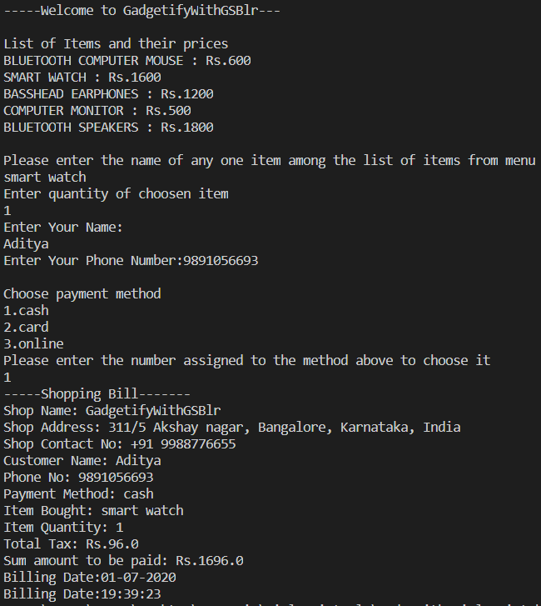

A Map data structure was used in this solution to store the shop items and their prices as key-value pairs. Two separate classes ShoppingCartEasy and Customer are used to separate the details of generating the bill and customer details.